**Linux Commands**

1. “pwd” is the command that is used to know the current working directory.

2. “ll” is the command to find out the contents vertically.

“ls” is the command to find out the contents horizontally.

3. The commands with inputs:

a-mkdir d1

b- mkdir d1/d2

c- cd d1/d2

d- touch f1.txt

e-cat f1.txt

f-ls ../

4. By using the ls command with its options, the directories from the listing can be identified using the “ls -l” command.

5. a. To list files with single character name we can use the “ls ?” command.

b. To list the hidden files “ls -la” command can be used.

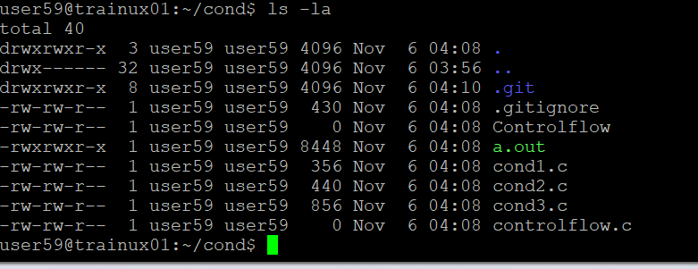

c. Suppose the files are tb1.1, tb2.1, tb3. 1, …. tb10.1. To list all the files “ls tb*.1” command can be used.

6. To list all files in descending order of their size “ls -ls” command can be used.

7. Suppose there are files temp1, temp2, temp3. “**rm temp**\*” command is used to remove the files without listing them explicitly.

8. **“head file_name”** command is used to list top few lines in the file.

9. To create a directory “testdir” the command “mkdir testdir” is to be used.

10. **cp command:**

a. In the same directory, to copy the file tb1.1 (created above), “cp tb1.1 tb1_copy.1” is used.

b. To copy all the files i.e. tb1.1, tb2.1, tb3.1,…..tb10.1 in a new directory –“new” ,

the commands are as follows:

“mkdir new

cp tb*.1 new/”

c. To create a subdirectory in new in named “new1”, “mkdir new/new1” command is used.

d. To copy only tb2.1, tb6.1, tb7.1 and tb10.1 in the directory new1, the command used is “cp tb2.1 tb6.1 tb7.1 tb10.1 new/new1”.

e. To copy the entire directory “new” to a directory “newprogs”. The command used is

“mkdir newprogs

cp -R new newprogs/”.

11. **Differences:**

a.

|  |  |
| --- | --- |
| **mv command** | **cp command** |
| 1. It is used when a file or a directory is supposed to be moved from one location to the another. | It is used when the contents of a file or a directory is supposed to be copied from one location to another location. |
| 1. The original content will be removed. | The original contents remained untouched. |
| 1. Use mv command when we want to move or rename files. | Use cp when we want duplicate files |

b.

|  |  |
| --- | --- |
| **rm command** | **rmdir command** |
| 1. The “rm” command is used to remove the entire file or directory erasing all the contents inside the file as well. | The “rmdir” command is used to remove only the empty directories. |
| 1. Deletes the specified files or directories. If used with -r option, it can delete directories and their contents. | Deletes the specified directories, but only if they are empty |

c.

|  |  |
| --- | --- |
| **mkdir command** | **mkdir -p** |
| 1. The mkdir command is used to create a directory only if ther eis parent directory. | mkdir -p is used to create a directory even if it does not have a parent directory. |
| 1. It will fail if any part of the specified path does not exist. | It will create all necessary parent directories. |

12. To remove “testdir” and all its sub directories and files created above, the command used is “rm -r testdir”.

13. man command is used to get the manual information. Syntax used:

“man command_name”.

14. If you are not able to change to a directory it could be likely because

a. The directory does not exist.

b. You do not have the necessary permissions to access the directory.

c. The path provided is incorrect.

15. The difference among the following commands is:

a. cd / : Changes to the root directory.

b. cd .. : Moves up one level to the parent directory.

c. cd : Changes to the user's home directory.

d. cd ../ : Moves up two levels to the grandparent directory.

